Physical Sciences 13 April 2024


By M.J. Mabodoko
Moderated by Mr A. Mgwali
Name: ____________________________________
School: ___________________________________
Introduction
Stoichiometric calculations can be integrated into any chemistry question. They can also be integrated into organic chemistry.
Leaners are given 25 minutes to complete this question.
This question covers nomenclature and reactions and stoichiometry and therefore is a good starting point to assess learner’s general grasp of the topic.

QUESTION 2 (Start on a new page.)
2.1 Consider the organic compounds represented by the letters A to C below.

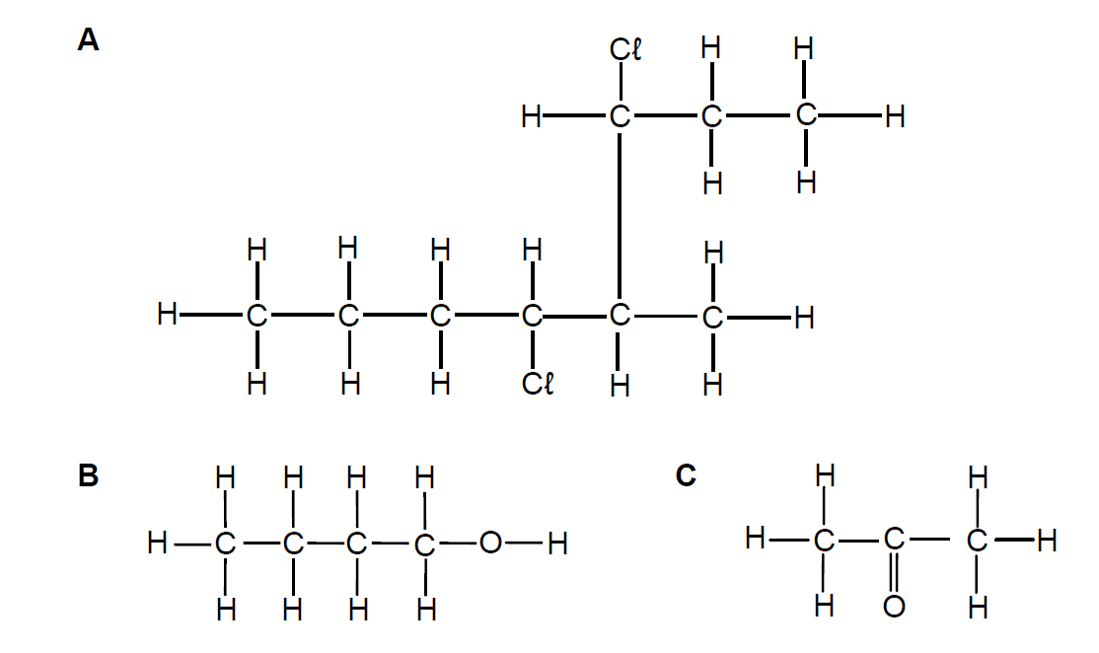

Write down the:
2.1.1 Name of the homologous series to which compound C belongs (1)
2.1.2 IUPAC name of compound A (3)
2.1.3 Structural formula of a tertiary alcohol that is a structural isomer of compound B (2)
2.2 An alcohol and methanoic acid are heated in the presence of concentrated sulphuric acid to form an ester.
2.2.1 What is the role of the concentrated sulphuric acid in this reaction? (1)
2.2.2 Write down the NAME or FORMULA of the inorganic product formed. (1)

The ester contains 6,67% hydrogen (H), 40% carbon (C) and 53,33% oxygen (O). The molar mass of the ester is 60 g·mol-1.
Use a calculation to determine its:
2.2.3 Empirical formula (5)
2.2.4 Molecular formula (3)
Write down the:
2.2.5 Structural formula of methanoic acid (1)
2.2.6 IUPAC name of the ester (2)
[19]

1. Most prevalent mistakes that learners make when Answering organic cheistry questions
  - Naming haloalkanes is still a challenge. Incorrect sequencing of substituents and/or omission or incorrect use of commas and hyphens were often found in answers of candidates. Some candidates did not write substituents in alphabetical order. ( Diagnostic Reports 2021,2020, 2018, 2017, 2015,2014)
  - It should be emphasised that halogens do not get preference when naming haloalkanes. All substituents, halogens and alkyl groups should be treated as equals and numbering should be such that the substituents have the lowest numbers. For example, 2,3,5 is smaller than 2,4,5. (taken from 2020 diagnostic report)
  - Confusion between types of isomers. Learners should be exposed to many exercises to practise the writing of IUPAC names and/or structural formulae of positional, functional and chain isomers of given compounds to ensure they can distinguish between the different types of structural isomers.
  - Making a general statement, e.g. ‘the longer the chain length, the higher the boiling point’, without referring to any of the given compounds
  - Referring to ‘energy needed to break the bonds’ (instead of ‘intermolecular forces’) or ‘energy needed to break the intermolecular forces’ between atoms (instead of ‘molecules’).
  - Only comparing the structural differences between the three isomers without comparing ‘the strength of the intermolecular forces’ and ‘the energy needed to overcome the intermolecular forces in each’.
  - Identification of primary, secondary and tertiary alcohols and giving reasons.
  - Merely stating that alkanes have single bonds between C atoms in Q3.1 is not enough because alkanes and alkynes also have single bonds between C atoms (2015, 2014 and 2017)
  - The mole concept and stoichiometry should form part of daily assessment across all chemistry topics.
  - Grade 11 work (Stoichiometry) is still poorly understood. Grade 11 work should be included in classwork, homework and tests in Grade 12.

Name these haloalkanes:

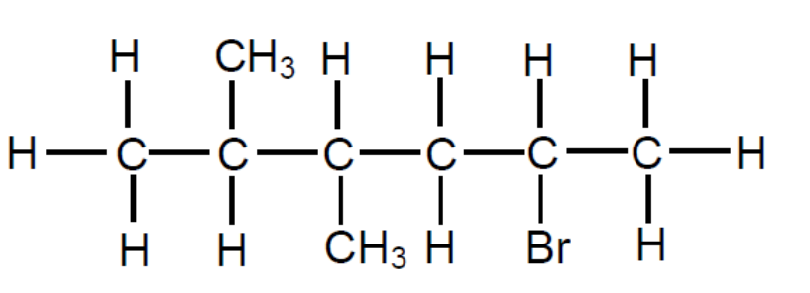
Name:
_____________________________________________________

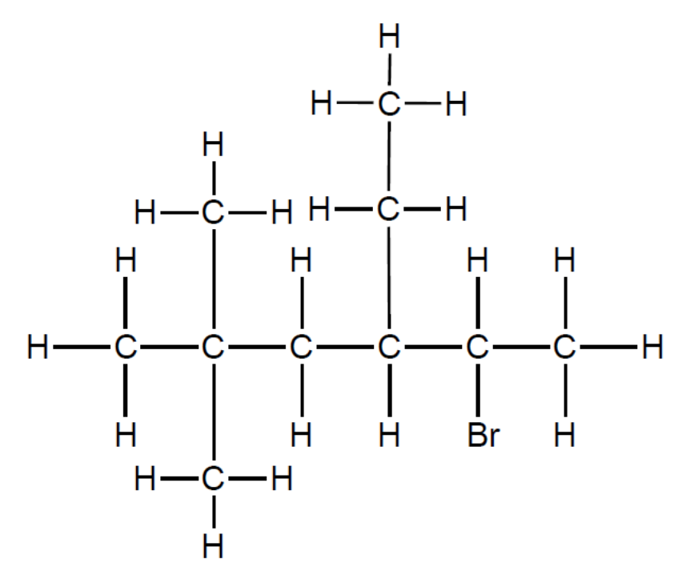
Name:
____________________________________________________

Functional Groups and general formulae
Homologous series | Alcohols | Carboxylic acids | Esters
Functional group | 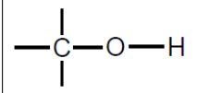  (hydroxyl) | 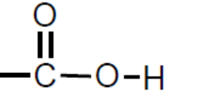  (carboxyl) | 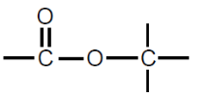
General formula | C_{n}H_{2n+2}O  also C_{n}H_{2n+1}OH | C_{n}H_{2n}O₂  also C_{n}H_{2n+1}COOH | C_{n}H_{2n}O₂

Homologous series | Functional  group | e.g. | General  formula
aldehydes | 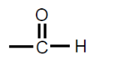 | butanal:  condensed structural formula:  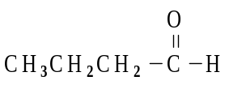  chemical formula:  C₄H₉CHO | C_{n}H_{2n}O
ketones | 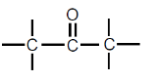 | butanone:  condensed structural formula:  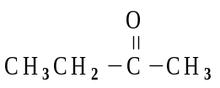  chemical formula:  C₃H₅COCH₃ | C_{n}H_{2n}O

Types of alcohols
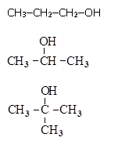
  - Alcohols are classified according to the number of carbon atoms attached to the hydroxyl group’s carbon
    - primary alcohol (1º): OH group’s C bonded
to 1 other C e.g. 1-propanol
    - secondary alcohol (2º): OH group’s C bonded to 2 other Cs e.g. 2-propanol
    - tertiary alcohol (3º): OH group’s C bonded to 3 other Cs e.g. methyl-2-propanol

Types of intermolecular forces
Intermolecular forces are the interactions that exist between molecules. The three different types of intermolecular forces that can exist between organic molecules are, in order of increasing strength:
- London (or dispersion) forces
- Dipole-dipole forces
- Hydrogen bonding

The table below summarises the cause of each of these intermolecular forces.

Type of force |  | Cause
 | London (or dispersion) forces | Caused by the interaction of temporary dipoles. All compounds exhibit London (dispersion) forces. • Larger surface area, stronger forces  • Larger, more polarisable atoms, stronger forces  WEAKEST
 | Dipole-dipole forces | Caused by the interaction between permanent dipoles of two polar molecules.  STRONGER
Hydrogen bonds |  | Caused by the electrostatic interaction of a H atom in a O-H, N-H, or H-F bond with the lone pair of an N, O or F atom in another molecule.  STRONGEST

Physical properties and IMF strengths
A stronger IMF gives a:
  - higher
    - melting point
    - boiling point
  - lower
    - vapour pressure
Comparing strengths of IMFs in organic compounds
Within a homologous series
    - type of IMF(s) the same
    - molecules with more 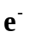 (i.e. bigger molar mass, M), have stronger IMFs, provided the number of branches the same
    - molecules with more branches have weaker IMFs, provided the number of e– are similar (i.e. similar M)
2.2 between different homologous series
    - molecules compared MUST have similar number of (i.e. similar M)
    - then differences due to different types / strengths of IMFs
2.3 Dominant IMF in different homologous series
    - hydrocarbons: very weak London forces between non-polar molecules
    - haloalkanes: weak London forces between slightly polar molecules
    - aldehydes and ketones: in addition to London forces they have slightly stronger dipole-dipole forces between more polar molecules
    - alcohols: in addition to London forces and dipole-dipole forces they have strong hydrogen bond between one pair of O and H of nearby molecules
    - carboxylic acids: in addition to London forces and dipole-dipole forces they have strong hydrogen bonds between two pairs of O and H of two nearby molecules

hydrogen bond in ethanol hydrogen bond in methanoic acid

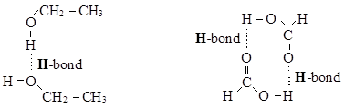

Reactions

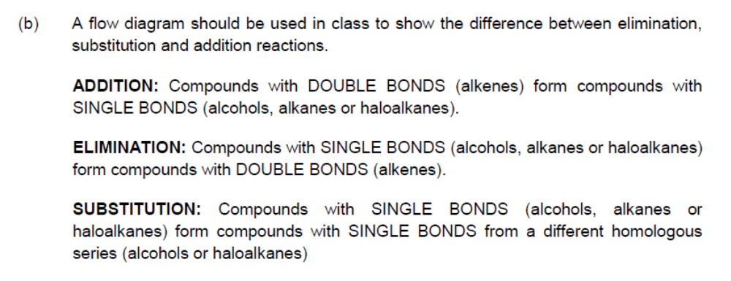

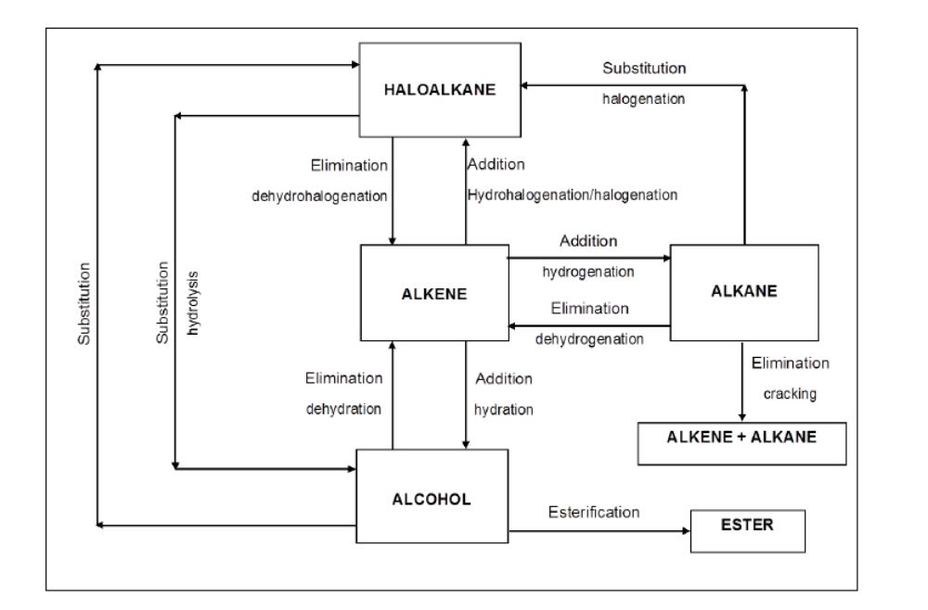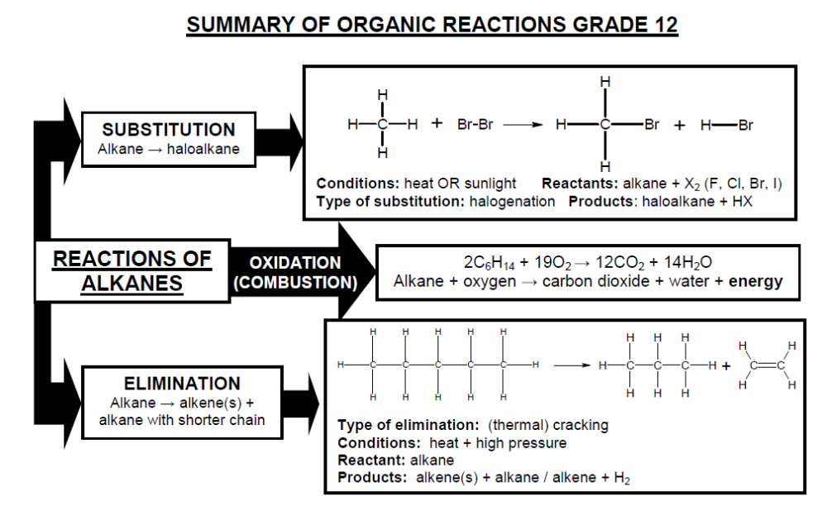
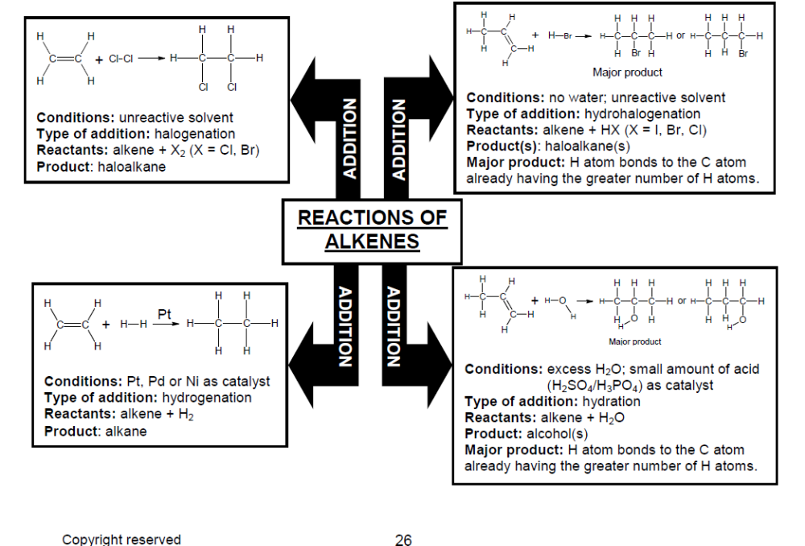
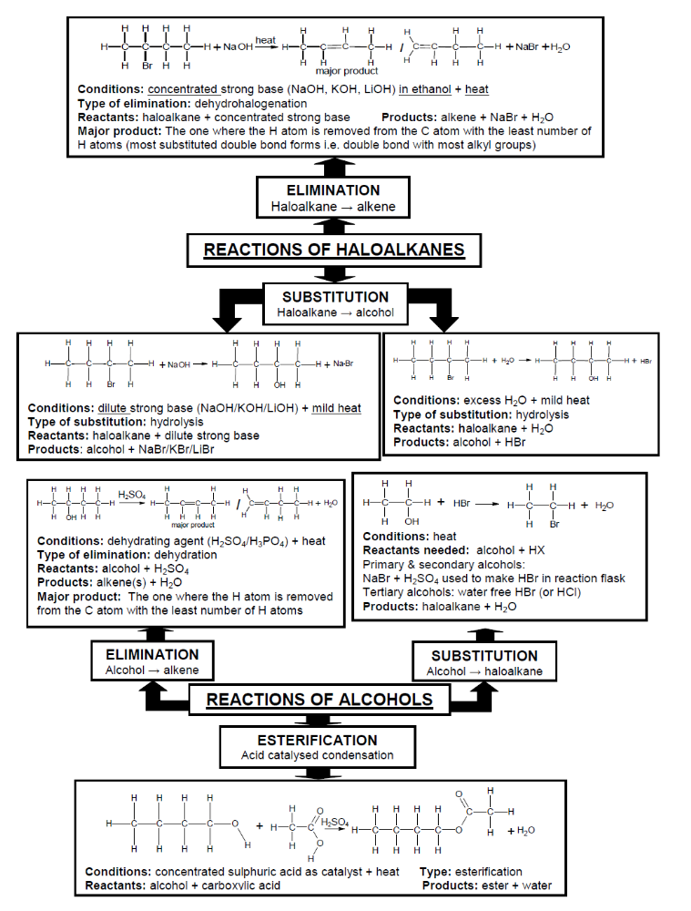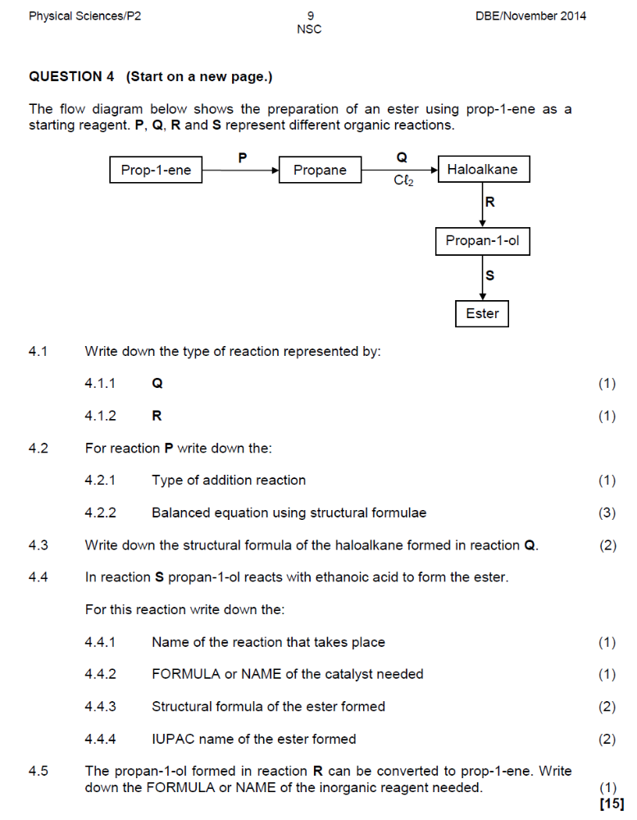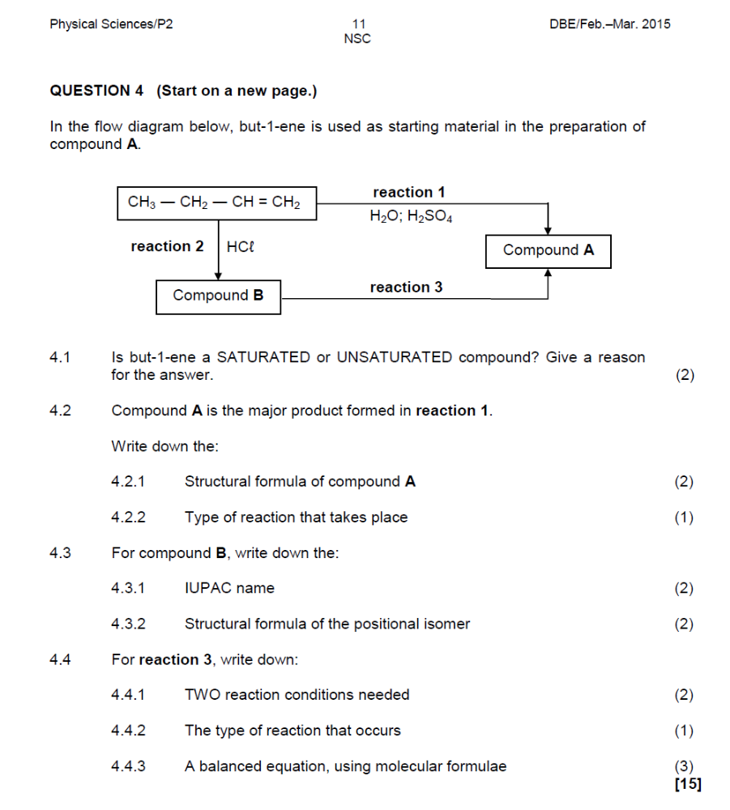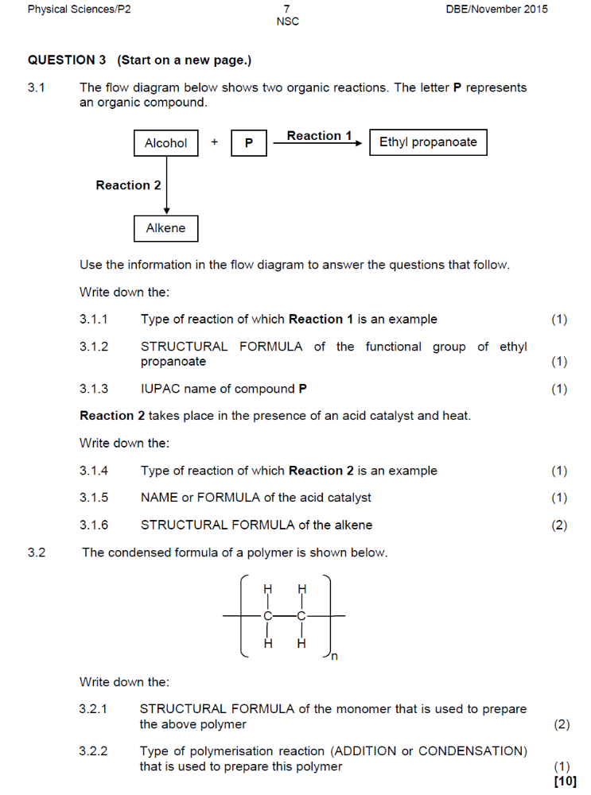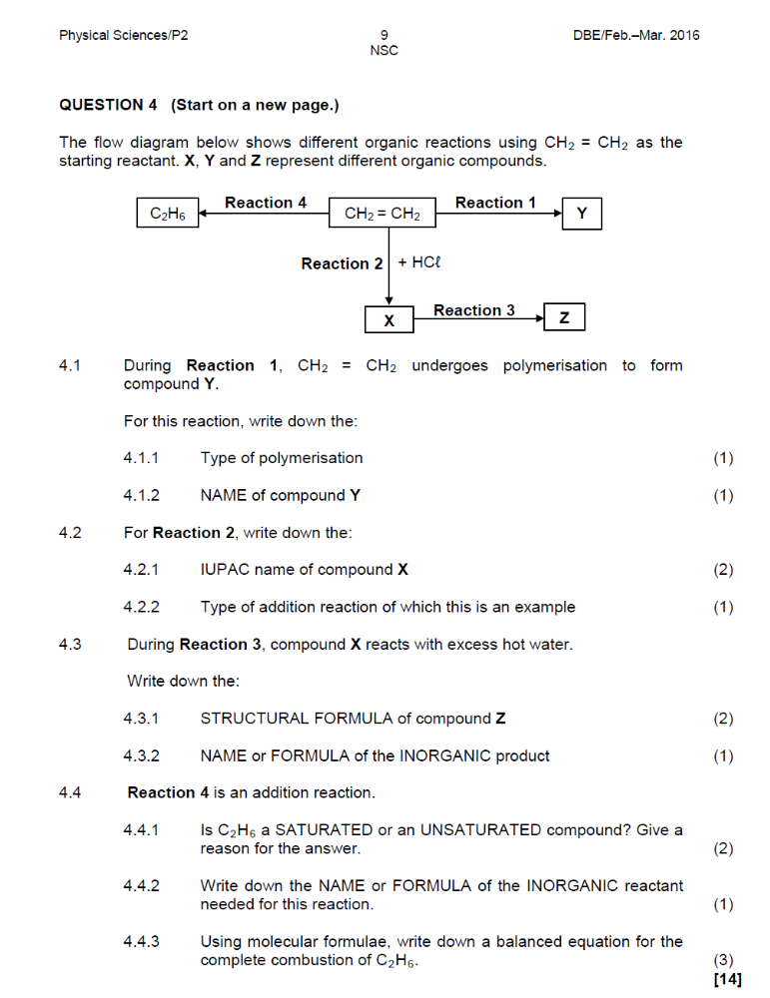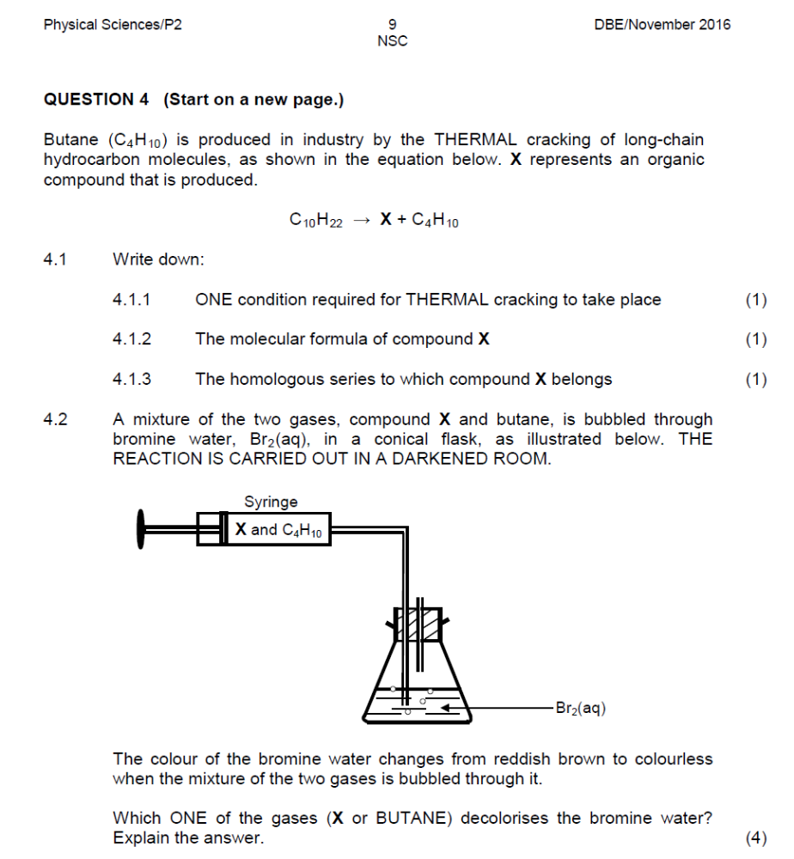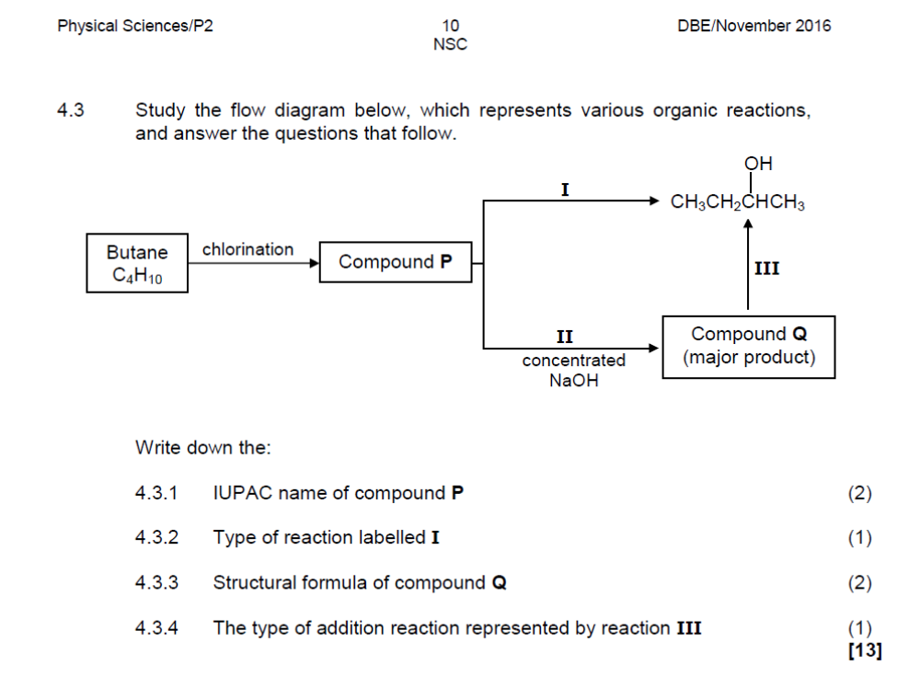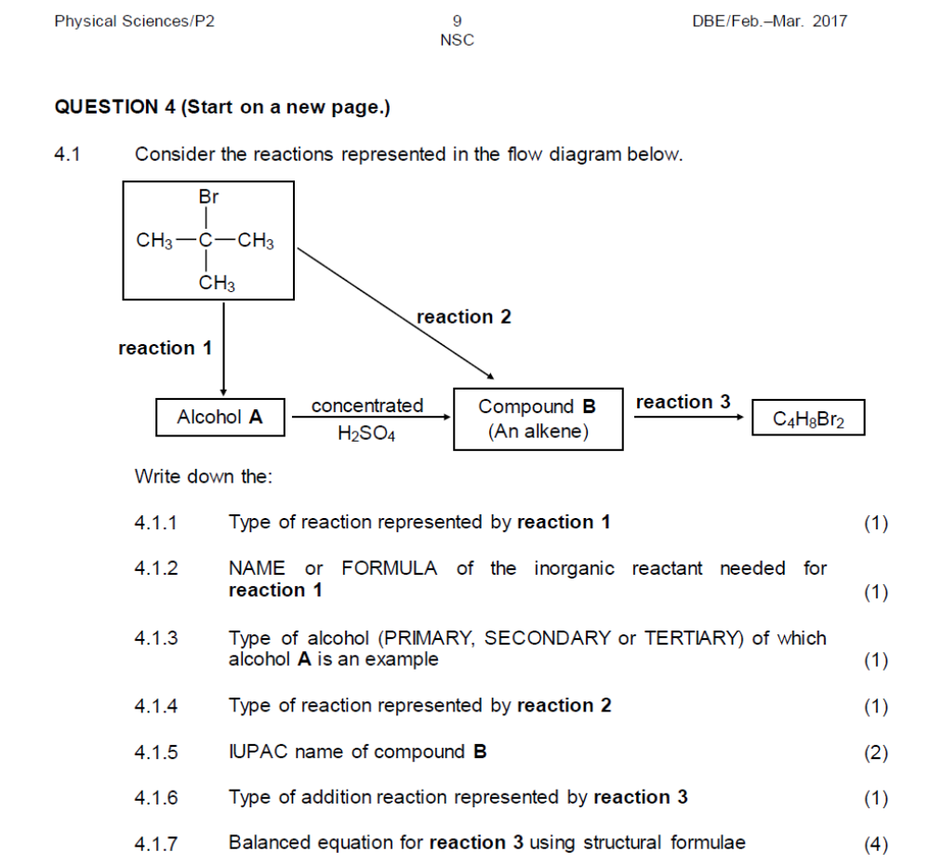

Practice questions

YEAR | QUESTION | COMMON ERRORS & MISCONCEPTIONS | SUGGESTIONS FOR IMPROVEMENTS
2015 | QUESTION 4 (Start on a new page.)  Four compounds of comparable molecular mass are used to investigate the effect of functional groups on vapour pressure. The results obtained are shown in the table below.  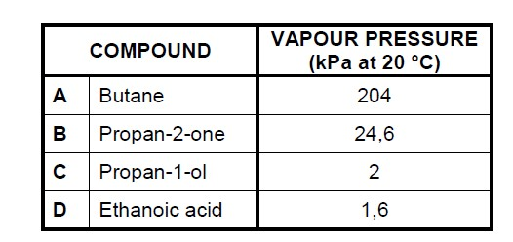  4.1 Define the term functional group of an organic compound. (2)  4.2 Which ONE of the compounds (A, B, C or D) in the table has the:  4.2.1 Highest boiling point (Refer to the vapour pressures in the table to give a reason for the answer.) (2)  4.2.2 Weakest intermolecular forces (1)  4.3 Refer to the type of intermolecular forces to explain the difference between the vapour pressure of compound A and compound B. (3)  4.4 The vapour pressures of compounds C and D are much lower than those of compounds A and B. Name the type of intermolecular force in A and B that is responsible for this difference. (1)  4.5 Briefly explain the difference in vapour pressure between compound C and compound D. (2)  4.6 During a combustion reaction in a closed container of adjustable volume, 8 cm³ of compound A (butane) reacts in excess oxygen according to the following balanced equation:  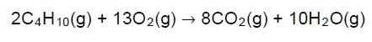  If the initial volume of the oxygen in the container was 60 cm3, calculate the TOTAL volume of the gases that are present in the container at the end of the reaction. All the gases in the container are at the same temperature and pressure. (5) | - The definition of a functional group (Q4.1) was poorly stated.  - When explaining the difference in vapour pressure of butane and propan2-one (Q4.3), many candidates did not specify the type of intermolecular forces i.e. London forces between molecules of alkanes and dipole – dipole forces between molecules of ketones. They only referred to Van der Waals’ forces.  - Many candidates did not give full explanations. They mentioned that Ethanoic acid had two sites for hydrogen bonding and propan-1-ol only one, but  then failed to link this to the strength of the IMFs  - Candidates incorrectly used the word  breaking ‘bonds’ instead of overcoming IMFS  - Q4.6 was poorly answered. Many candidates failed to identify the limiting reagent and apply stoichiometry to organic reactions. | (a) Ensure that learners know basic definitions through frequent questioning as well as informal tests. (b) Expose learners to different stoichiometric calculations during their Grade 12 year to ensure that they stay familiar with such calculations..
YEAR | QUESTION | COMMON ERRORS & MISCONCEPTIONS | SUGGESTIONS FOR IMPROVEMENTS
2017 | QUESTION 3 (Start on a new page.)  The vapour pressure versus temperature graph below was obtained for four straight chain (unbranched) alkanes (P, Q, R and S).  FROM P TO S, EACH COMPOUND DIFFERS FROM THE PREVIOUS COMPOUND BY A –CH2 GROUP.  The vapour pressures are measured in mmHg. Atmospheric pressure is 760 mmHg.  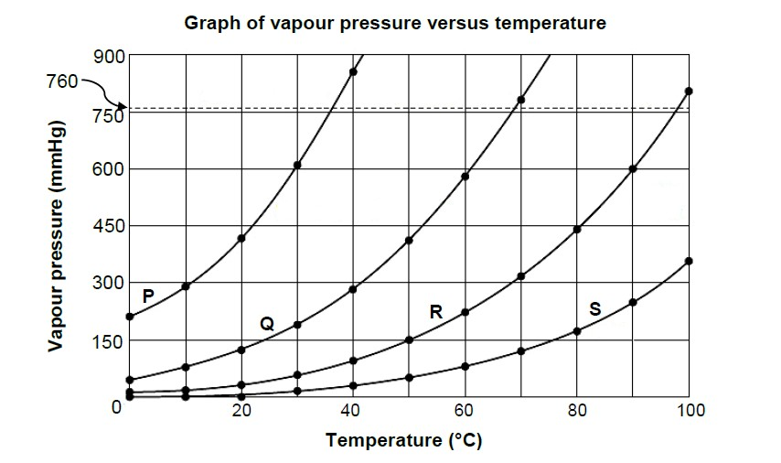  3.1 Give a reason why alkanes are said to be SATURATED. (1)  3.2 Define vapour pressure. (2)  3.3 Use the information in the graph above to answer the following questions.  3.3.1 What is the effect of an increase in temperature on vapour  pressure? Choose from INCREASES, DECREASES or  NO EFFECT. (1)  3.3.2 Which compound has a boiling point of approximately 68 °C? Give a reason for the answer. (2)  3.3.3 Which compound has the longest chain length? Fully explain the answer. (4)  3.4 Compound P has FIVE carbon atoms.  3.4.1 Draw the structural formula of a chain isomer of P. Write down the  IUPAC name of this isomer. (3)  3.4.2How will the vapour pressure of this isomer compare with that of compound P? Choose from HIGHER THAN, LOWER THAN or EQUAL TO. (1)  [14] | - Merely stating that alkanes have single bonds between C atoms in Q3.1 is not enough because alkanes and alkynes also have single bonds between C atoms.  - Candidates experienced difficulty to provide a definition of vapour pressure in Q3.2.  - Interpretation of the graph in Q3.3.2 was a challenge for many candidates. They  failed to see that the boiling points of the compounds are the temperatures at which each of the graphs cuts the dotted line which represents atmospheric pressure. (d) In Q3.3.3, many learners failed to refer to the variables (labels on the axes of the graph) in their explanations. Most learners failed to compare the vapour pressures of the four compounds at a particular temperature.  (e) In Q3.4.1, some candidates found the drawing of the chain isomer of  pentane challenging. | - The safest and easiest reason why alkanes are considered saturated is that alkanes have no multiple bonds.  - Ensure that learners understand the meaning of a particular definition. For example,  the definition of vapour pressure is about the pressure exerted by a vapour in equilibrium with its liquid phase (liquid ⇌ vapour) in a closed system.  - When using a graph to answer a particular question, learners should be taught to refer to the variables.

